Friendship Week in
Plymouth Devon
BOOKING FORM

Surname Given names e-mail Telephone

Address IPA membership IPA Section

List of guests in company
Surname Given names e-mail Telephone

Number Total

Event Date
attending
cost £

Cornwall tour 14th September, 2020 .

at £ 25.00 per person 18th September, 2020 .

Devon tour 14th September, 2020 .

at £ 35.00 per person 18th September, 2020 .

BBQ & Military evening ** 17th September, 2020 .

at £15.00 per person

Gala dinner 19th September, 2020 .

at £50.00 per person

Special needs/diets/comment:
Grand total .

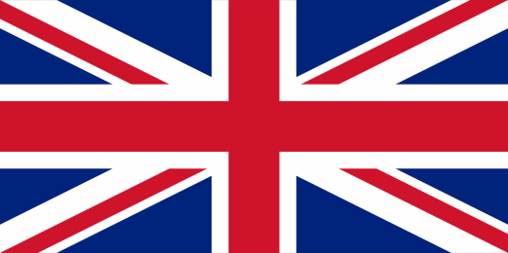 [** Photo ID to be shown at military base entrance to gain entry, e.g. passport. Your date of birth and country of birth are required by us, in advance, for Military security checks. Please help us by providing these details at time of booking.]

PAYMENT METHODS
ALL TO BE MADE IN GBP - POUND STERLING BY 12th JUNE, 2020
- ANY FOREIGN CURRENCY TRANSACTION CHARGES TO BE BORNE BY PAYEE

CHEQUES - payable to IPA 7 Region

POST to Treasurer IPA 7 Region - 17 Edmonds Close, Buckingham, MK18 1YR

UK BACS - IPA 7 Region - sort code: 309668 account # 04908047

INTERNATIONAL BANK TRANSFER IBAN : GB89 LOYD 3096 6804 9080 47 BIC : LOYDGB21082 Address: Royal Parade Plymouth 309668, Birmingham OSC, Ariel House, 2138 Coventry Road, Sheldon B26 3JW Email completed form to 7 Region Treasurer— ipamayflower400@gmail.com

